1 Eddie Nicholson
2 Judy Pittson
3 …..Booker
4 Andy Preston
5 ….Booker
6 ……….
7 Helen Palmer
8 ….. Pittson
9 Robert Palmer
10 ….. Pittson
11 Ros Bourne
12 Val Gebbett
13 Jane Booker
14 Hilary Palmer
15 …..Butler
16 Tom Pittson
17 Paul Gebbett
18 Brenda Butler
19 Alan Beardsley
20 Peter Bourne
21 …..
22 …..Bourne
23 Andrew Buckland
24 Steven Wright
25 Mike Napier
26 ……..
27 ……..
28 ……..
29 ……..
30 Jos Yarnell
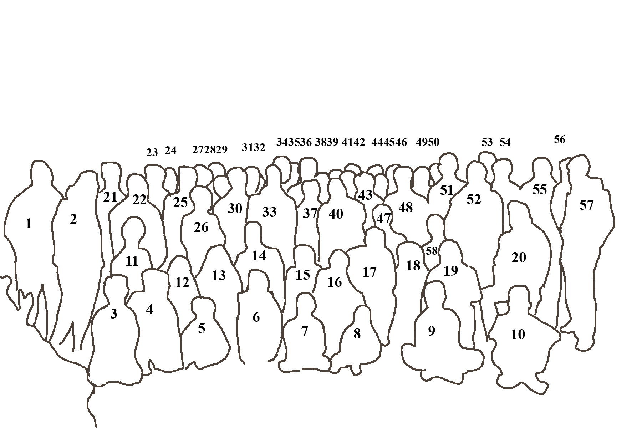

31 …….
32 …….
33 Tim Hills
34 ……...
35 ……
36 ……
37 ……
38 ……
39 ……
40 Dave Smalley
41 Jim Clarke
42 Alan Gould
43 Janet Evans
44 Geoff Allen
45 Kath Wright
46 Nick Evans
47 ……
48 Mick Lucking
49 Richard Butler
50 Peter Preston
51 John Palmer
52 David Booker
53 ……
54 Peter Hubberstey
55 Tony Horsewill
56 Keith Picksley
57 Phil Pittson
58 Angela Lucking

NOC Compass Sport Cup Team

